**1. Write a Python program to calculate the length of a string.**

**Program** -

strl ="NagpurisLove"

n = len(strl)

print(n)

**output -**

16

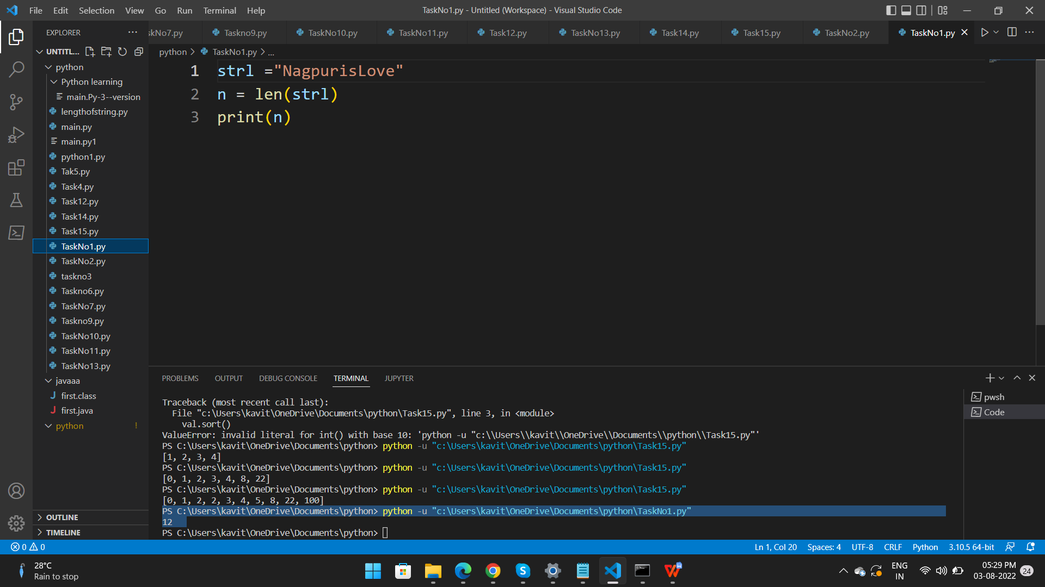

1. **Task 2 of ingle string from two given strings, separated by a space and swap the first two characters of each string.**

v2,v1 ="abcd","wxyz"

temp = v2

v2 = v1[0:2] + v2[2:]

v1 = temp[0:2] + v1[2:]

print(v2+' '+v1)

**Output -**

wxcd abyz

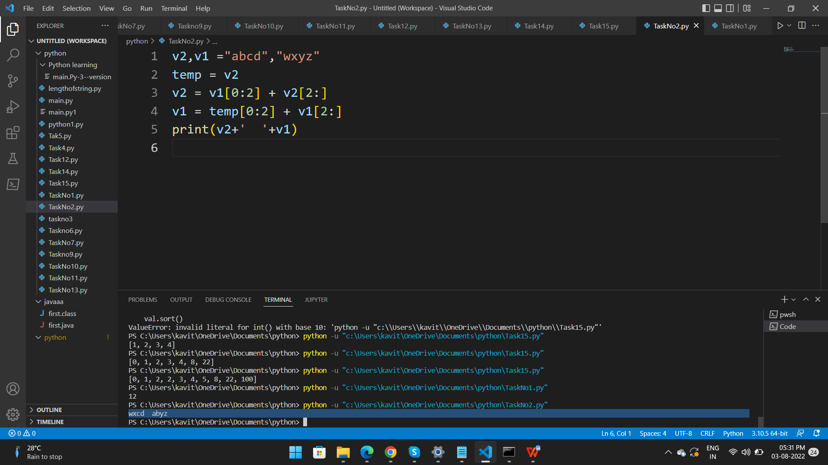

1. **Write a Python function that takes a list of words and return the longest word and the length of the longest one**

**Sample Output**

**Longest word: Exercises**

def find_longest_word(words_list):

word_len = []

for n in words_list:

word_len.append((len(n), n))

word_len.sort()

return word_len[-1][0], word_len[-1][1]

result = find_longest_word(["JAVA", "Exercises", "SELENIUM"])

print("\nLongest word: ",result[1])

print("Length of the longest word: ",result[0])

Output -

Longest word: Exercises

Length of the longest word: 9

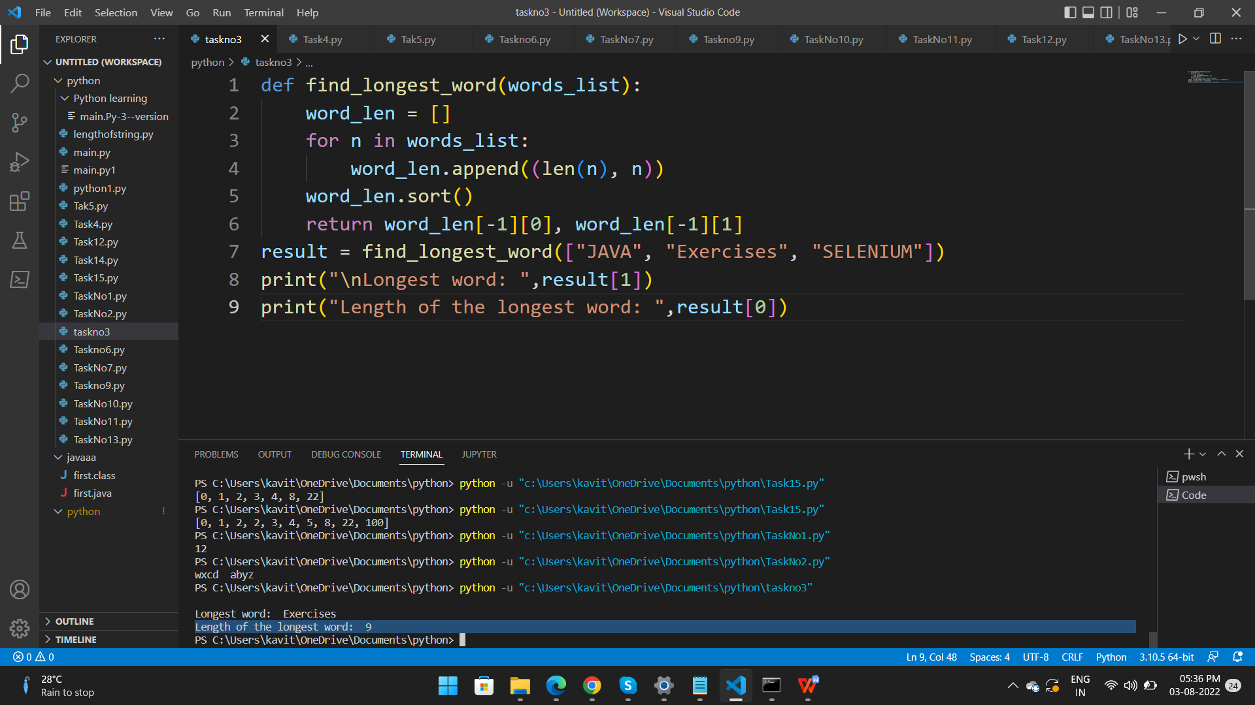

1. **Write a Python program to add a prefix text to all of the lines in a string**

import textwrap

sample_text ='''

Salesforce is a leading CRM (Customer Relationship Management) software which is served form cloud.

It has more than 800 applications to support various features like generating new leads, acquiring new leads,

increasing sales and closing the deals. It is designed to manage the organization's data focused on customer and sales details.

It also offers features to customize its inbuilt data structures and GUI to suit the specific needs of a business. More recently,

it has started offering the IOT (internet of things) connectivity to the CRM platform.

'''

text_without_Indentation = textwrap.dedent(sample_text)

wrapped = textwrap.fill(text_without_Indentation, width=50)

#wrapped += '\n\nSecond paragraph after a blank line.'

final_result = textwrap.indent(wrapped, '> ')

print()

print(final_result)

print()

**Output** -

Relationship Management) software which is served

> form cloud. It has more than 800 applications to

> support various features like generating new

> leads, acquiring new leads, increasing sales and

> closing the deals. It is designed to manage the

> organization's data focused on customer and sales

> details. It also offers features to customize

> its inbuilt data structures and GUI to suit the

> specific needs of a business. More recently, it

> has started offering the IOT (internet of things)

> connectivity to the CRM platform.

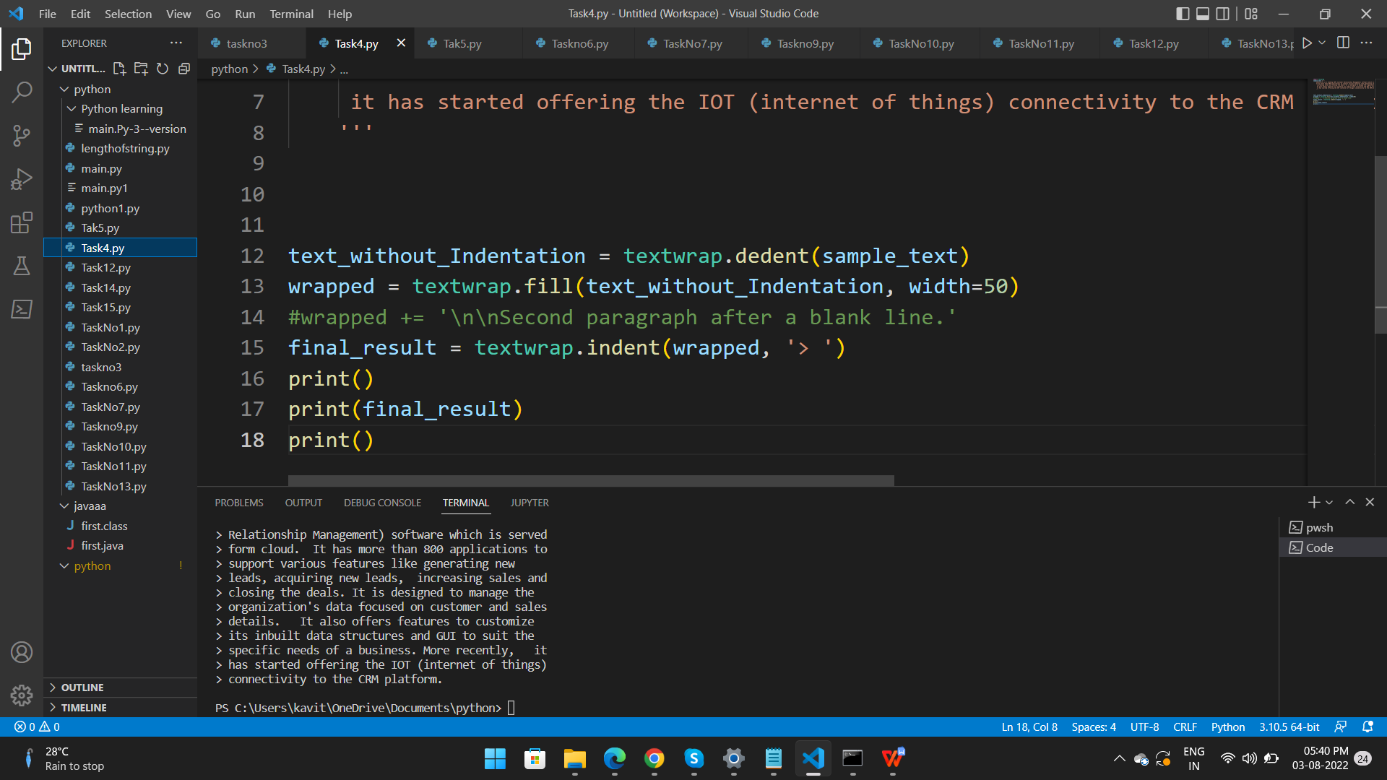

1. **Write a Python program to lowercase first n characters in a string.**

str1 ='SALESforce'

print(str1[:5].lower() )

**Output**-

Salesforce

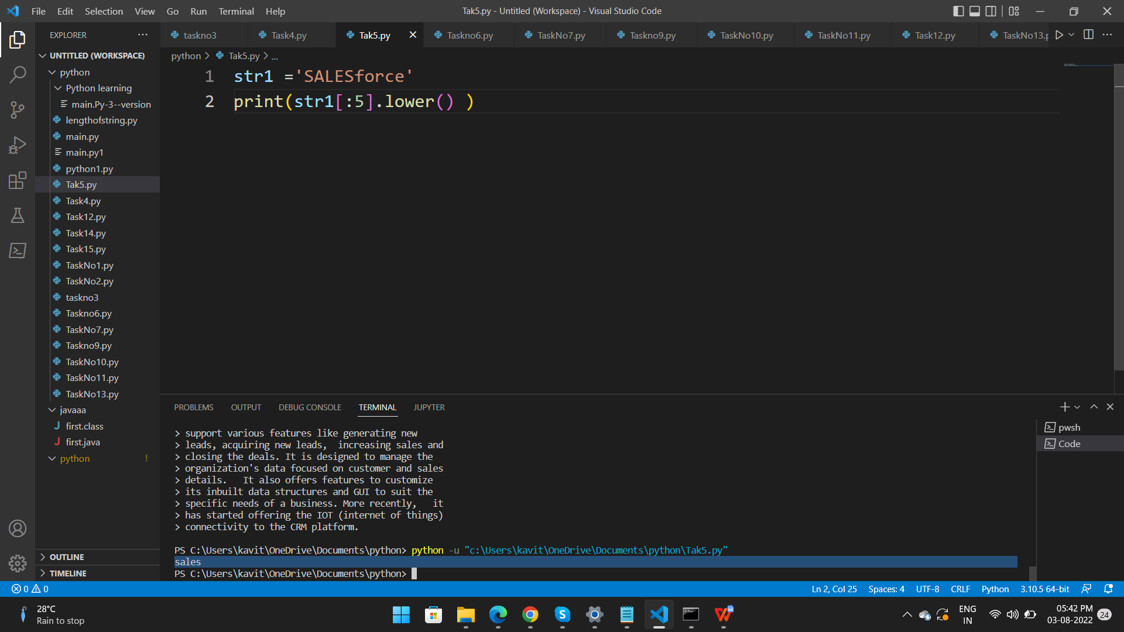

**Task 6. Write a Python program to remove spaces from a given string.**

str=input("Enter any line of string")

str1=""

s=str.split()

for i in range(0,len(s)):

str1=str1+s[i]+" "

print("String with extra space ",str)

print("String without extra spaces",str1)

Output -

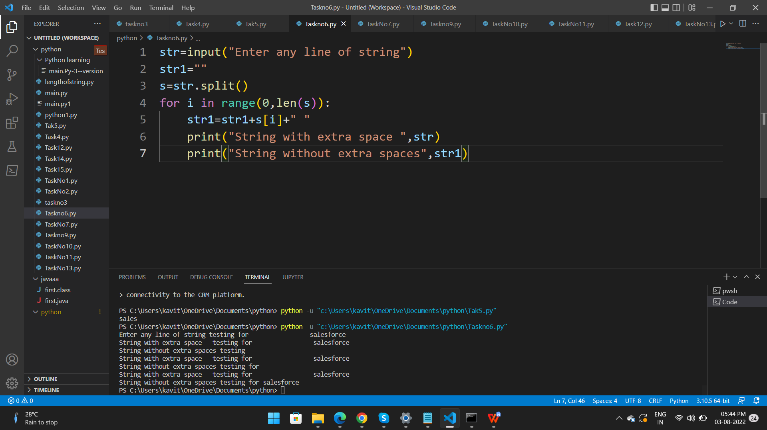

**Task 7.  Write a Python program to remove unwanted characters from a given string.**

**Sample Output:**

**Original String : Pyth*^on Exercis^es**

**After removing unwanted characters:**

**Python Exercises**

str="Pyth*^on Exercis^es"

special ="*^"

for i in special:

str=str.replace(i,"")

print(str)

**Output-**

Python Exercises

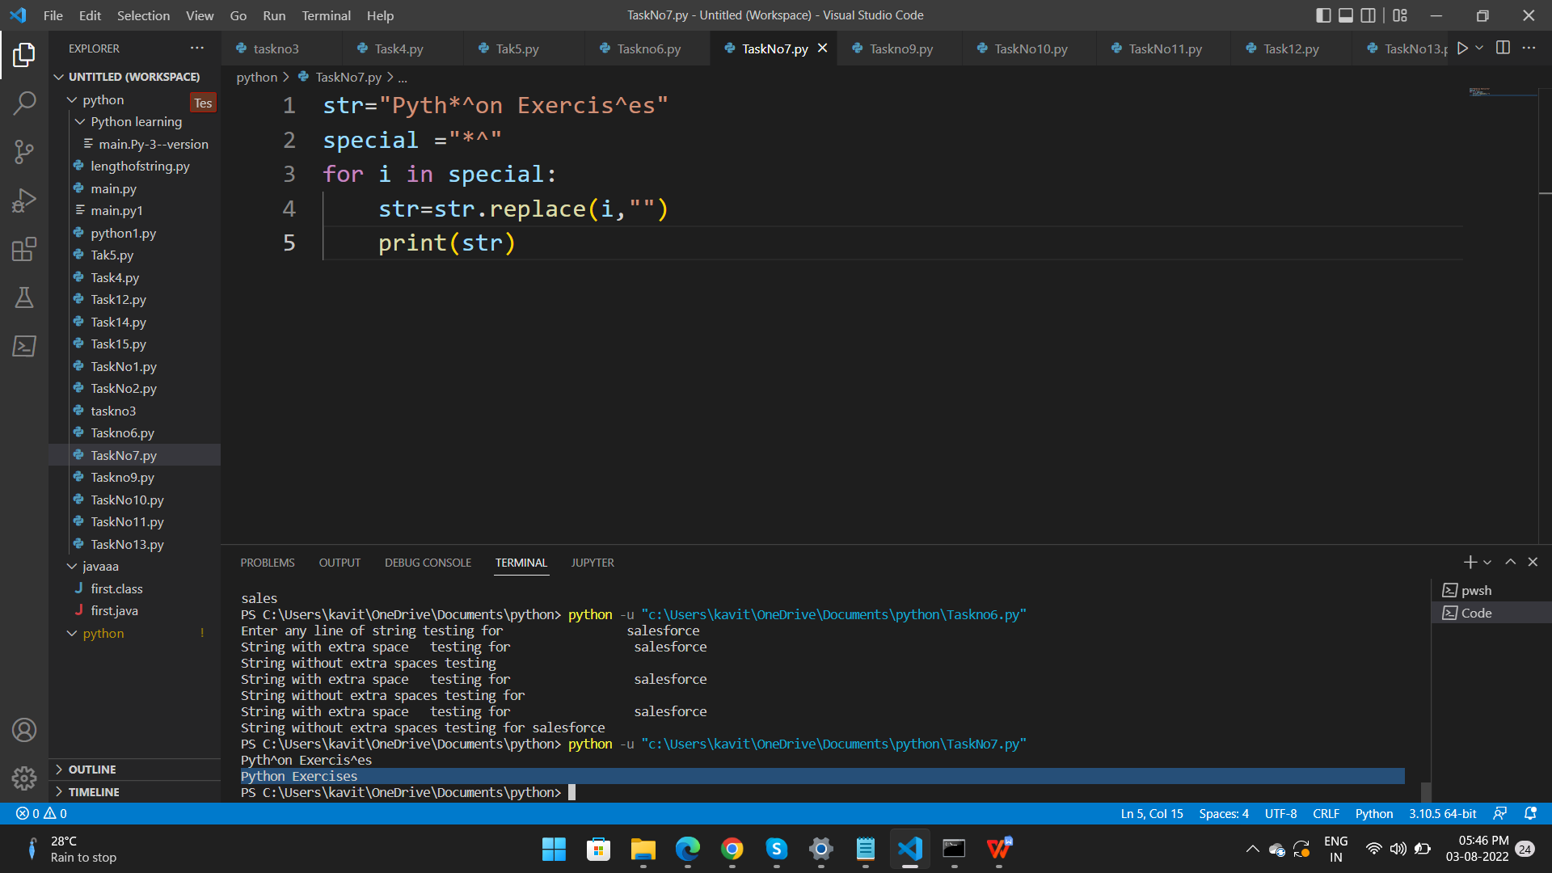

**Task 9. Write a Python program to get the largest number from a list**

def largestnumber(numbers):

biggest_num = numbers[0]

for num in numbers:

if num > biggest_num:

biggest_num=num

return biggest_num

print(largestnumber([1,29,70,36]))

**output** - 70

**Task10. Write a Python program to access the index of a list.**

a=["Mohit","shyam","kavita"]

x=a.index("kavita")

print("Index of kavita=",x)

output -

PS C:\Users\kavit\OneDrive\Documents\python> python -u "c:\Users\kavit\OneDrive\Documents\python\TaskNo10.py"

Index of kavita= 2

PS C:\Users\kavit\OneDrive\Documents\python>

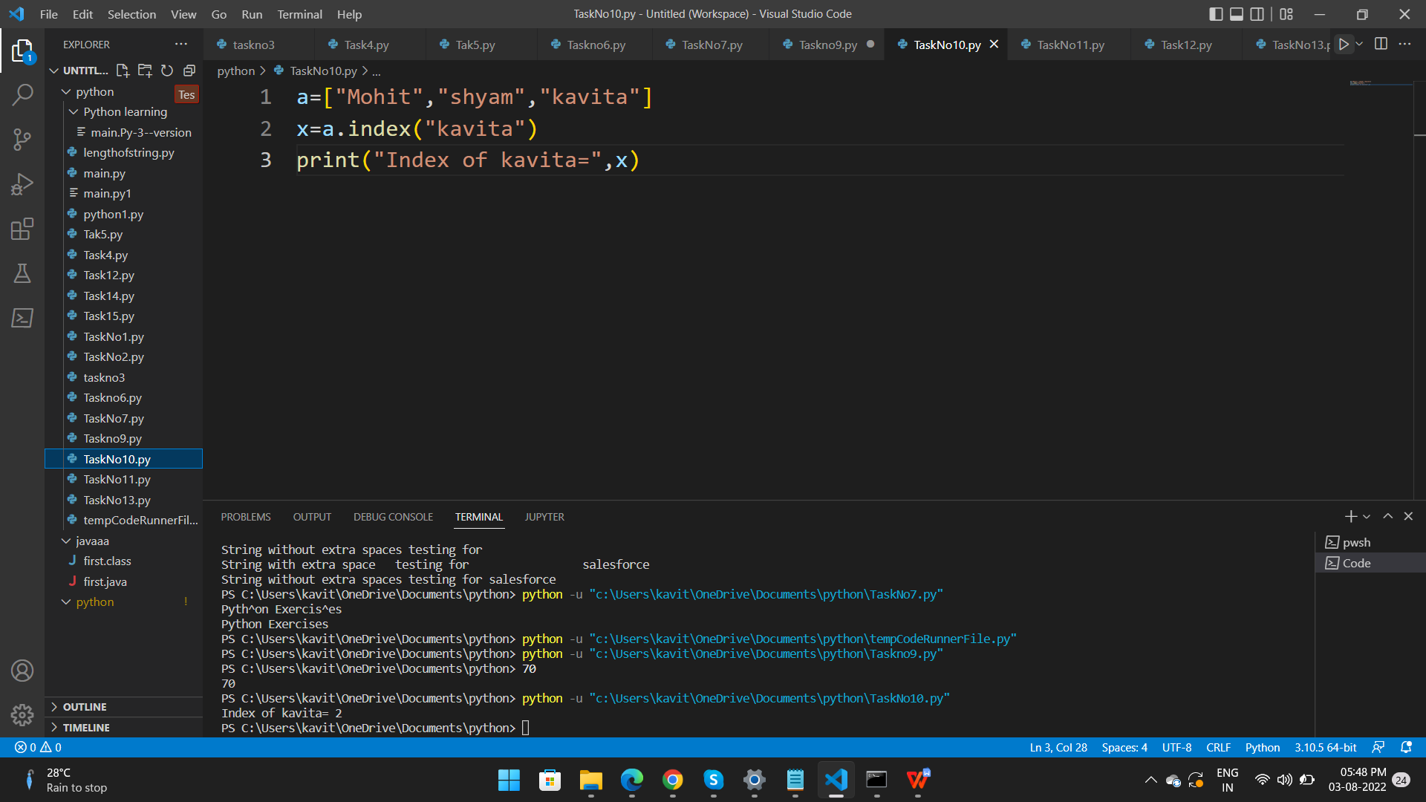

**Task 11. Write a Python program to append a list to the second list.**

list1 = [1,2,3,4,0]

list2 =['Pink','Green','Blue']

final_list = list1 + list2

print(final_list)

output-

PS C:\Users\kavit\OneDrive\Documents\python> python -u "c:\Users\kavit\OneDrive\Documents\python\TaskNo11.py"

[1, 2, 3, 4, 0, 'Pink', 'Green', 'Blue']

PS C:\Users\kavit\OneDrive\Documents\python>

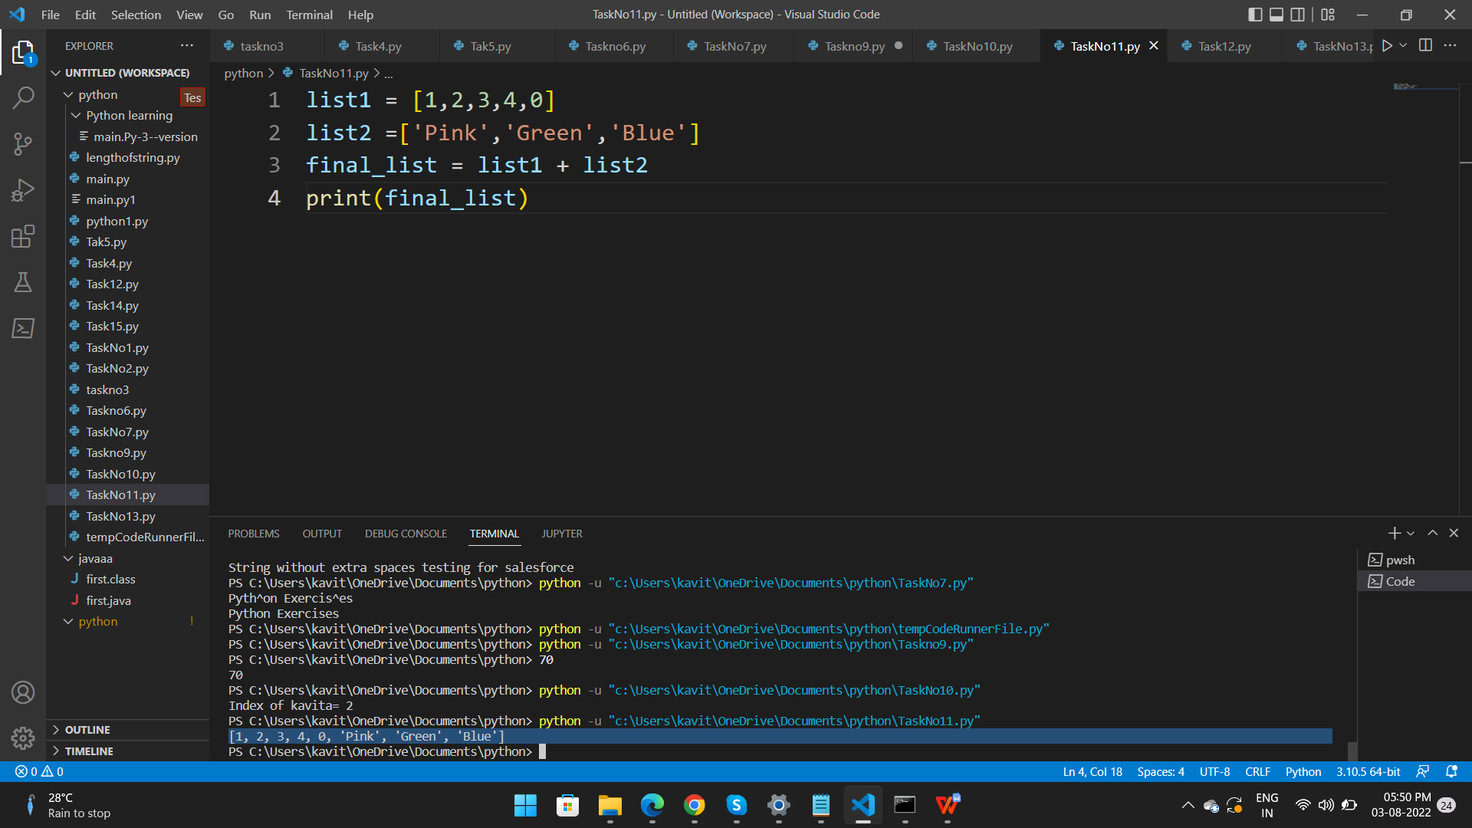

**Task 12. Write a Python program to get unique values from a list.**

li=['python','testing','360degree','testing','salesforce','python']

x = dict.fromkeys(li)

print(x)

**Output**

PS C:\Users\kavit\OneDrive\Documents\python> python -u "c:\Users\kavit\OneDrive\Documents\python\Task12.py"

{'python': None, 'testing': None, '360degree': None, 'salesforce': None}

PS C:\Users\kavit\OneDrive\Documents\python>

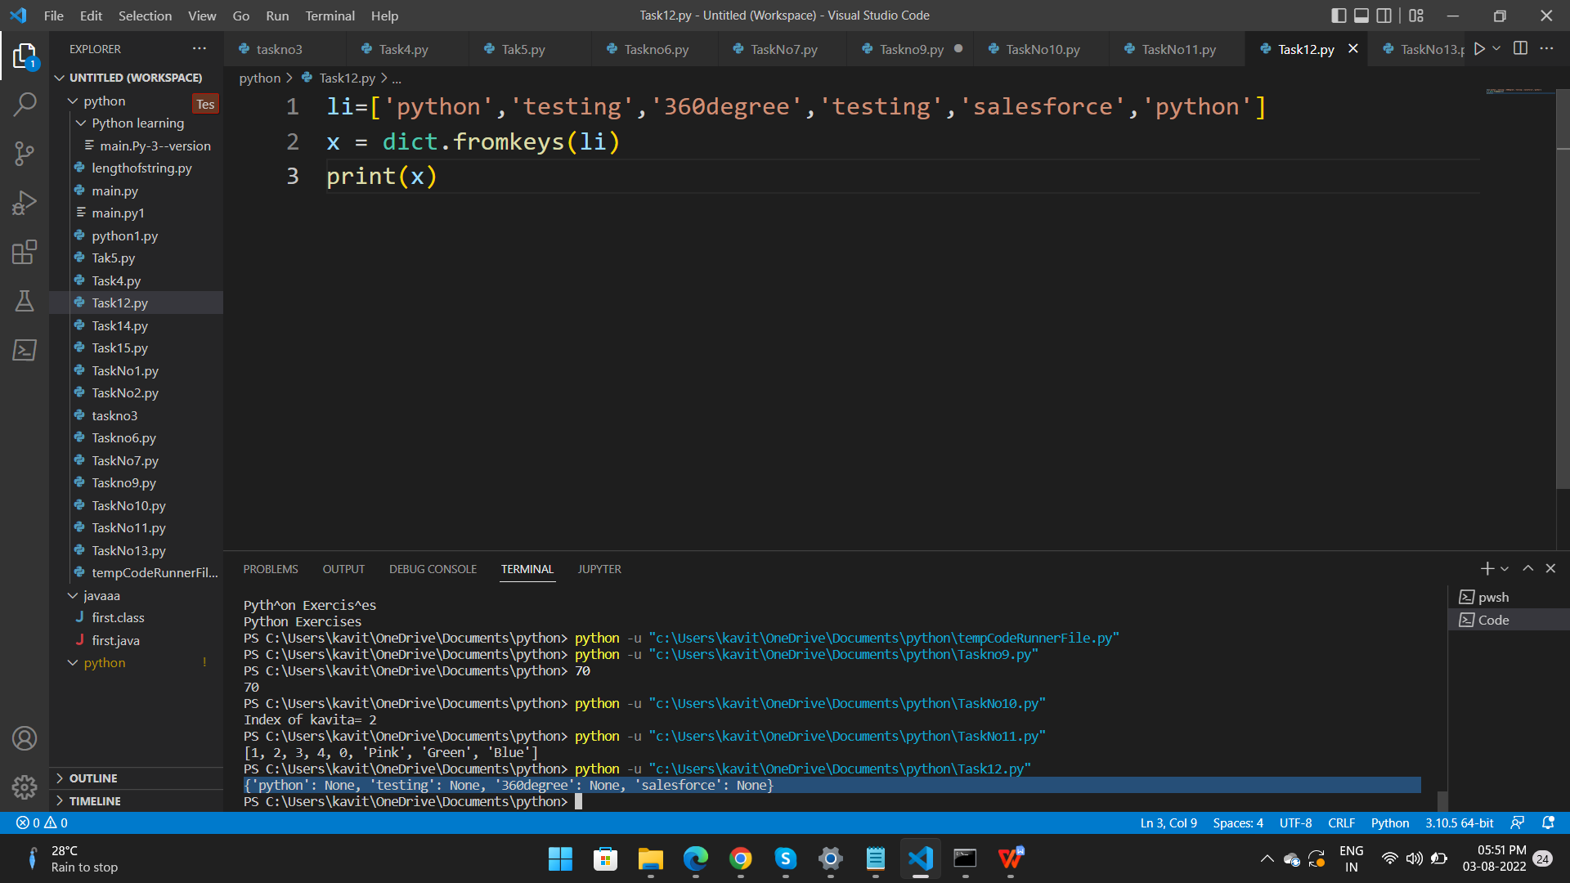

**Task13. Write a Python program to find common items from two lists.**

color1="Red","Green", "Pink"

color2 ="black","green","Red","White"

print(set(color1) & set(color2))

**Output**-

PS C:\Users\kavit\OneDrive\Documents\python> python -u "c:\Users\kavit\OneDrive\Documents\python\TaskNo13.py"

{'Red'}

PS C:\Users\kavit\OneDrive\Documents\python>

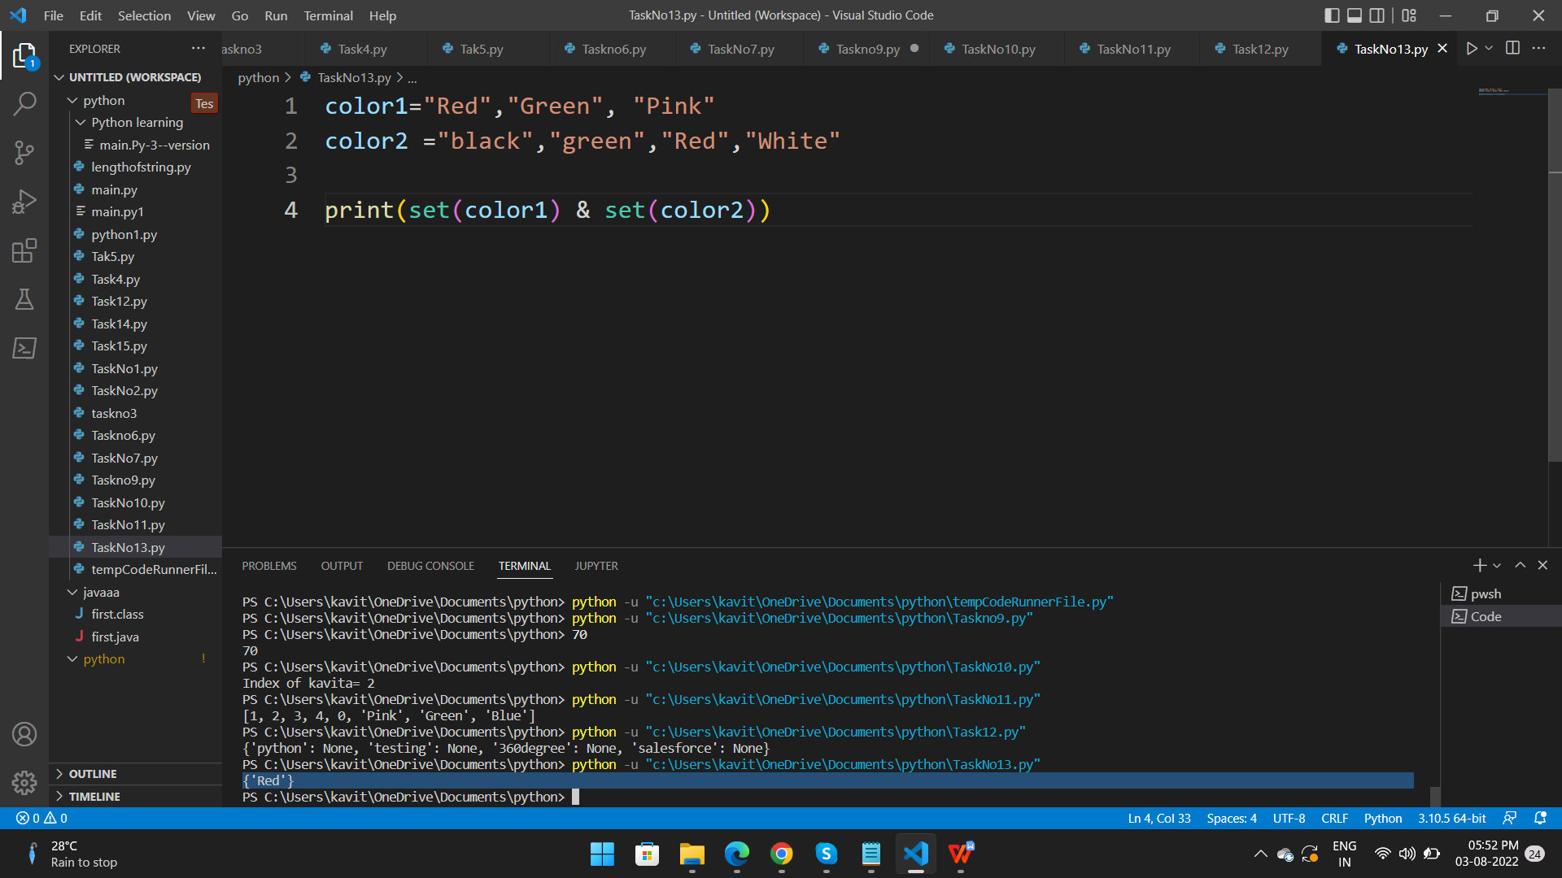

**Task 14. Write a Python program to split a list based on the first character of a word.**

text = "welcome to salesforce"

print("The string is spliting on basis of white space")

print(text.split())

**Output**

The string is spliting on basis of white space

['welcome', 'to', 'salesforce']

PS C:\Users\kavit\OneDrive\Documents\python>

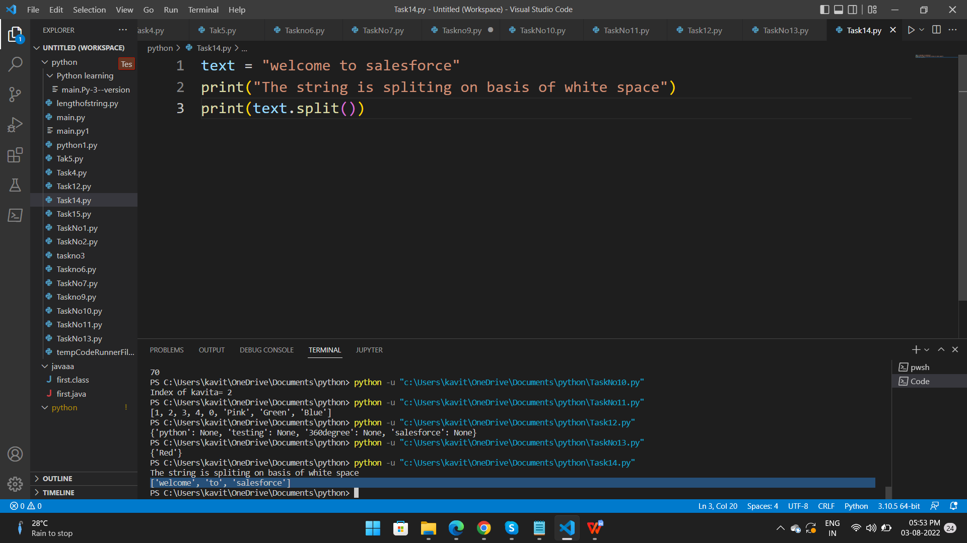

**Task 15. Write a Python program to sort a list.**

numbers = [1, 3, 4, 2,8,0,22,100,2,5]

# Sorting list of Integers in ascending

numbers.sort()

print(numbers)

**output**-

PS C:\Users\kavit\OneDrive\Documents\python> python -u "c:\Users\kavit\OneDrive\Documents\python\Task15.py"

[0, 1, 2, 2, 3, 4, 5, 8, 22, 100]

PS C:\Users\kavit\OneDrive\Documents\python>

